Review Sheet for Renaissance and Reformation – 2015
The Renaissance
Italian Merchants and role in the Crusades
Italian Merchants and Trade – what was in demand? New trading Centers
Silks, Sugar, and Spices
Women during the Renaissance – Role with the Family
Italian City State – Florence, Venice, Rome, etc. (Why important?) Who lost their power as the city states gained theirs?
Artwork in the Renaissance (Famous works we covered) Be able to identify differences between Northern and Italian Artwork. Did both Northern and Italian have religious themes?
Leonardo da Vinci’s background – famous paintings, famous sculptures, famous architecture, famous inventions, and mathematical contributions.
Petrarch’s Background – Role in the development of Humanism
Humanism’s (define) effect on education
Baldassare Castiglione – The Book of Courtier
Chaucer’s Canterbury Tales
Desiderius Erasmus – His effect on Christian Humanist
Girolamo Savonarola
Francesco Sforza
Dante
Northern vs. Italian Artwork
Know the Following Works – David - Michelangelo, David – Donatello, School of Athens Raphael, Mona Lisa - Leonardo da Vinci, Botticelli – Birth of Venus
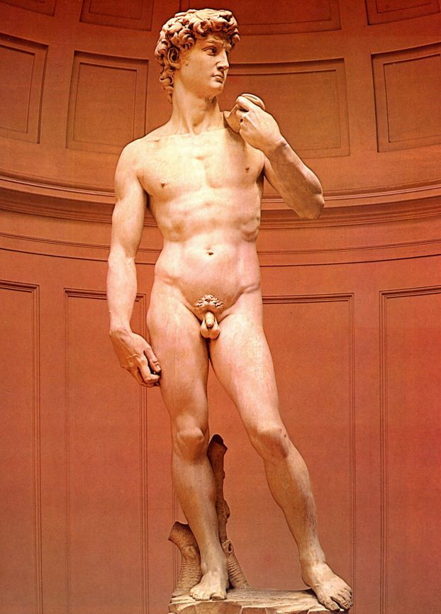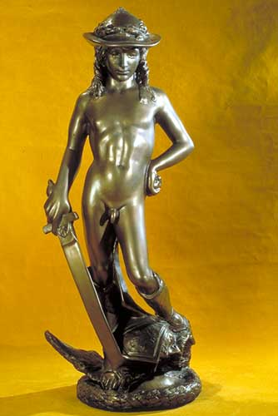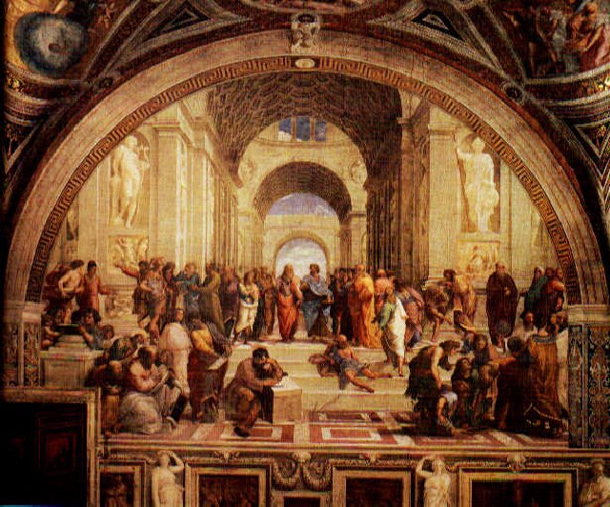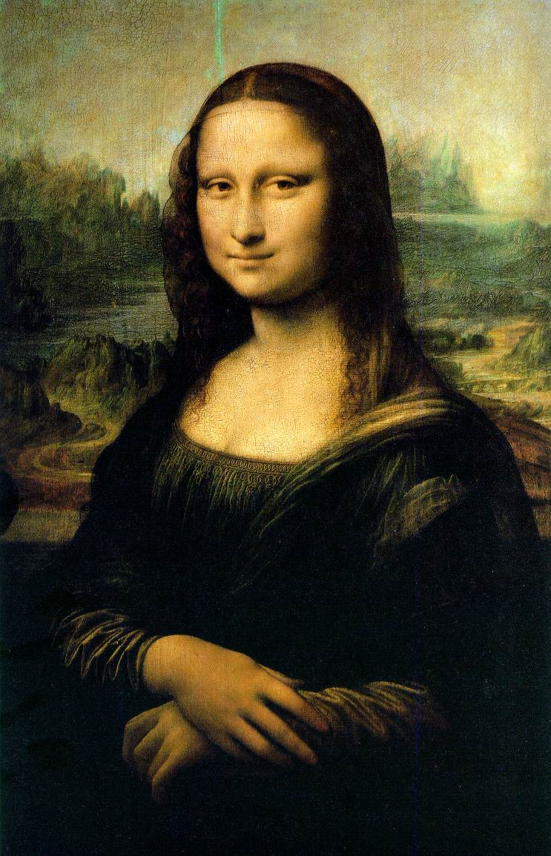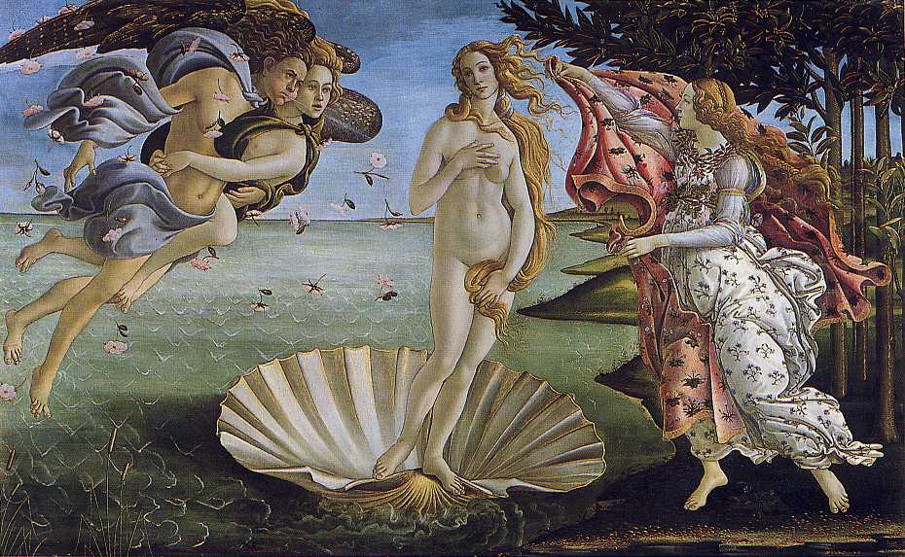
The Reformation
What were some of the changes Luther wanted to see in the Catholic Church? (Marriage of clergy, sacraments, etc.)
Martin Luther’s background – Lightning, Justification of Faith, Married, etc.
Luther’s 95 Thesis – Where? When? What? Why?

John Calvin’s background – France, Geneva, Protestantism, Consistory etc.
Calvin vs. Luther Similarities and Differences
What was the first Protestant faith?
Huldrich Zwingli

Predestination
Peace of Augsburg – what did it do to Germany?
Council of Trent – What did it decree?
Edict of Worms
Despite Protestants developing a new view of the family what didn’t happen with Protestant women and mothers.

Henry VIII

Anabaptists

Annulment
Ignatius of Loyola

